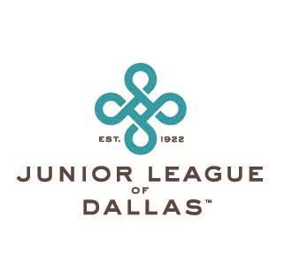
The Junior League of Dallas Lifetime Achievement Award
As a celebration of the 105th Anniversary of the Junior League of Dallas, the Lifetime Achievement Award for excellence in voluntarism and community leadership will be announced in June and presented at the 2026-2027 Milestones Luncheon. This distinguished award is presented to a Sustaining member of the Junior League of Dallas who has been a catalyst for positive community change and who has consistently demonstrated leadership skills and vision.

Sustaining and Active JLD members may nominate women whom they feel are worthy of consideration. Nominators are asked to submit names of League members who have lived the JLD mission through their JLD service and beyond, demonstrated outstanding leadership, and have made a lasting impact on our community.
The recipient of the Lifetime Achievement Award will be a Sustaining member of the Junior League of Dallas who meets the following criteria:

- Exemplifies JLD principles of commitment and community leadership, multiculturalism, vision, and innovation
- Is a role model, mentor, catalyst, and risk-taker making an exceptional and lasting contribution to the community

- Takes a comprehensive approach to community problem-solving, advocacy, coalition building, direct service, and public education
- Faces obstacles, takes risks, and devotes the necessary time to pursue her vision

- Takes the time to understand and develop the technical skills and knowledge required to reach the vision
- Brings others into her vision
- Is creating local impact with national/international implications

If you have questions about the nomination process or award, please contact Sustainer President Elect, Joanna Clarke. Applications will be accepted from March 2 through April 1, 2026. Please send nominations to joannaclarke07@gmail.com or Lifetime Achievement Award, JLD, 8003 Inwood Road, Dallas, TX 75209-3335. You may also obtain an application on our website, www.jlDallas.orgt

Please provide the information listed below regarding your nominee. Please indicate whether the nominee’s community work has been done as a volunteer or as a paid staff/consultant.

- What League positions have been held by the nominee, including her community program involvement and her affiliations with community organizations?

- How has the nominee demonstrated the criteria for the Lifetime Achievement Award through her community involvement and service outside of the League?

