Grants for Innovative Teaching Application Instructions
Step 1: Read about Grants for Innovative Teaching!
Read up on Grants for Innovative Teaching. We have a sample of the application and budget on the website. We also have our FAQs. Click here to access that information under “Additional Resources”.

Step 2: Download and Fill Out the Application and Budget Form.
- Download the GFIT Application and the GFIT Budget Form to your computer.
- Complete the application and save as a PDF file.
- Complete the budget form and save as an Excel file.

Step 3: Upload Application and Budget Form.
- Click on “Upload 2024-2025 Application and Budget”
- Fill out all fields below:
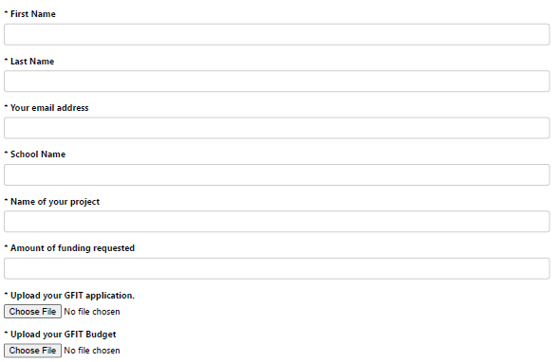
- Click on “Choose File” under GFIT application and GFIT Budget to upload each separate document. Please remember to save GFIT application as PDF and GFIT Budget as Excel.
- Click Submit.
Congratulations! You have submitted your application and budget form. A member of the Junior League of Dallas will be in touch in May/June. Should you have any questions, please contact GFIT@jldallas.org.
DEADLINE: APRIL 15th at 11:59 PM – NO EXTENSIONS WILL BE GRANTED

